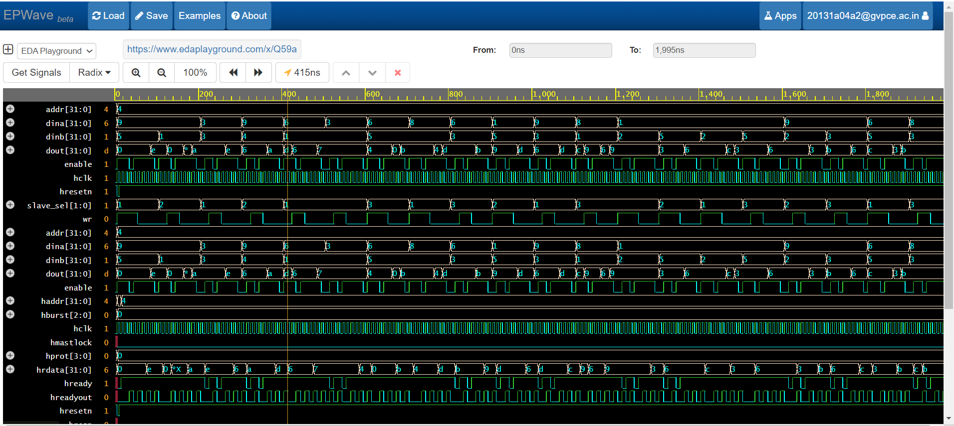

UVM_INFO coverage.sv(45) @ 1995: uvm_test_top.env.m_cov [APB_SUBSCRIBER] sampled tx   
# Coverage Percentage: 70.83%  
# outputs matched  
# -------------------------------------------  
# Name Type Size Value  
# -------------------------------------------  
# req mem_sequence_item - @634   
# hclk integral 1 'h0   
# hresetn integral 1 'h0   
# enable integral 1 'h0   
# dina integral 32 'h8   
# dinb integral 32 'h3   
# addr integral 32 'h4   
# wr integral 1 'h0   
# slave_sel integral 2 'h3   
# dout integral 32 'hb   
# -------------------------------------------  
# -------------------------------------------  
# Name Type Size Value  
# -------------------------------------------  
# req1 mem_sequence_item - @615   
# hclk integral 1 'h0   
# hresetn integral 1 'h0   
# enable integral 1 'h0   
# dina integral 32 'h8   
# dinb integral 32 'h3   
# addr integral 32 'h4   
# wr integral 1 'h0   
# slave_sel integral 2 'h3   
# dout integral 32 'hb